[Project Name]
Process Model

Date | [May 18, 2010]
Version | [1.1]
Status | [Type document status here]
Author | [Doan Thi Trang, Developer]
Reviewed by | [Le Phi Hung, Project Manager]
Approved by | [Nguyen Thi Thanh Thuy, Director]

Revision History

Date | Version | Description | Author
<May 18, 2010> | <1.0> | <details> | <Le Minh Vuong>
<May 21, 2010> | <1.1> | <fix format> | < Doan Thi Trang>

Table of Contents
1 Introduction 4
1.1 Purpose 4
1.2 Scope 4
1.3 Definitions, Acronyms and Abbreviations 4
1.4 References 4
1.5 Overview 4
2 Process View 5
2.1 sCMS 5
2.1.1 Change Key 5
2.1.2 Clear card 6

Introduction

Purpose
[This section describes the system's decomposition into lightweight processes (single threads of control) and heavyweight processes (groupings of lightweight processes). Organize the section by groups of processes that communicate or interact. Describe the main modes of communication between processes, such as message passing, interrupts, and rendezvous.

This view is OPTIONAL. Use this view only if the system has more than one thread of control, and the separate threads interact or are dependent upon one another]

Scope
<Provide a short description of the software being specified and its purpose, including relevant benefits, objectives, and goals. Relate the software to corporate goals or business strategies. If a separate vision and scope document is available, refer to it rather than duplicating its contents here. An SRS that specifies the next release of an evolving product should contain its own scope statement as a subset of the long-term strategic product vision.>

Definitions, Acronyms and Abbreviations

No | Term | Description

References
<List any other documents or Web addresses to which this SRS refers. These may include user interface style guides, contracts, standards, system requirements specifications, use case documents, or a vision and scope document. Provide enough information so that the reader could access a copy of each reference, including title, author, version number, date, and source or location.>

Overview

Process View

sCMS
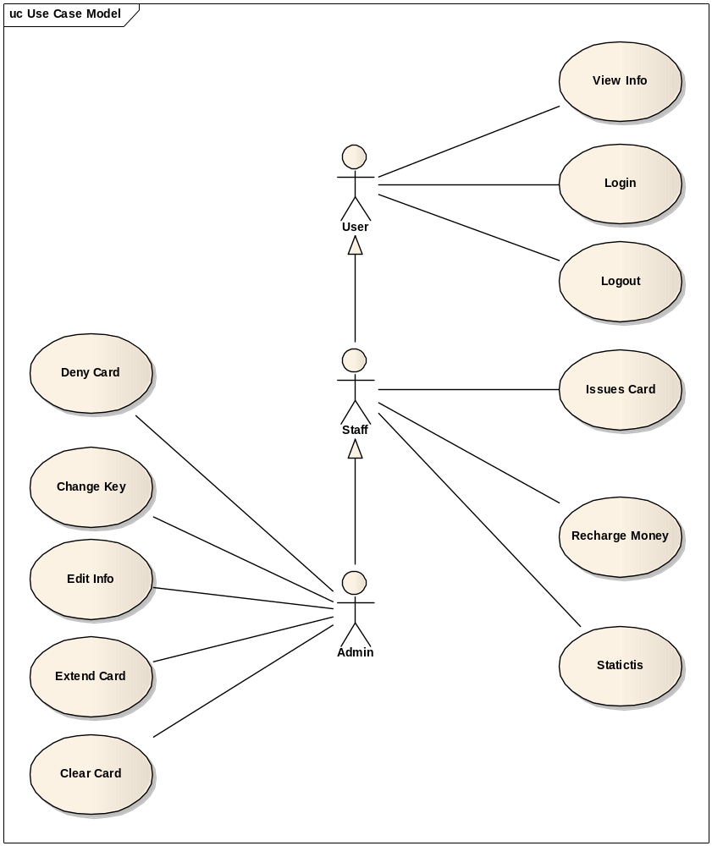

Change Key
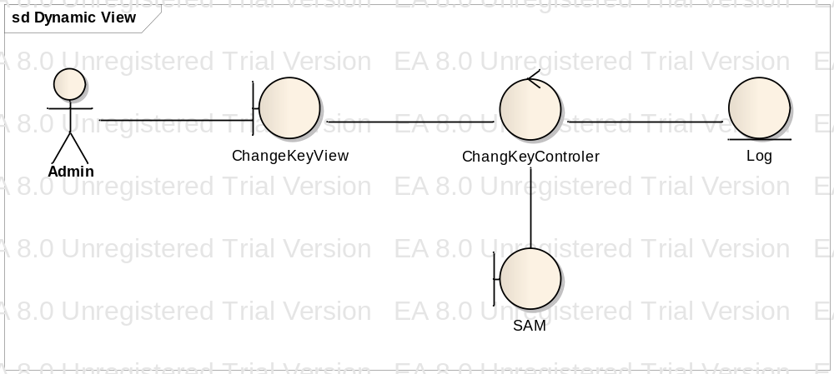

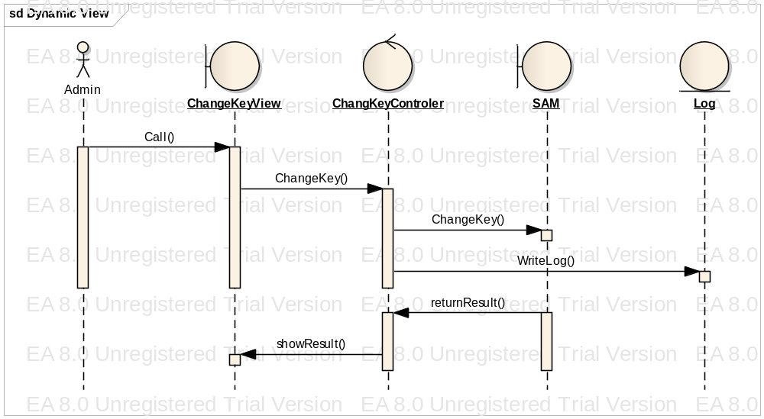

Clear card
